Name:_______________



Year 11 Modern History

Unit 1 Understanding the Modern World

Elective 7: Capitalism – the American Experience 1907–1941

**Source Analysis One (5%)**

**Conditions** Marks: /25

Time for the task: 10 minutes reading time, 45 minutes working time.

A source booklet consisting of four (4) sources which have been selected by the teacher.

Answer the questions (a) to (e) using the four (4) sources that have been provided.

1. Compare and contrast the messages of Sources 1 and 2. (4 marks)

Hint: What does the creator want you to think, feel or believe for each of the sources (1 mark for stating what the message is for each of the sources)? What is similar about the sources (1 mark)? What is different about the sources (1 mark)?

________________________________________________________________________________________________________________________________________________________________________________________________________________________________________________________________________________________________________________________________________________________________________________________________________________________________________________________________________________________________________________________________________________________________________________________________________________________________________________________________________________________________________________________________________________________________________________________________________________________________________________________________________________________________________________________________________________________________________________________________________________________________________________________________________________________________________________________________________________________________________________________________________________________________________________________________________________________________

1. Evaluate the usefulness of Sources 1 and 2 as representations of the attitudes towards changes in the USA in the 1920s. (5 marks)

Hint: Give a judgement on whether the two sources teaches us anything about the changes in attitudes in the 1920s. Provide examples of Source 1 as a representation of attitudes towards change (2 marks). Provide examples of Source 2 as a representation of attitudes towards change (2 marks). Evaluate the usefulness of the sources, is this evidence that tells us what it was like in the period? (1 mark).

______________________________________________________________________________________________________________________________________________________________________________________________________________________________________________________________________________________________________________________________________________________________________________________________________________________________________________________________________________________________________________________________________________________________________________________________________________________________________________________________________________________________________________________________________________________________________________________________________________________________________________________________________________________________________________________________________________________________________________________________________________________________________________________________________________________________________________________________________________________________________________________________________________________________________________________________________________________________________________________________________________________________________________________________________________________________________________________________________________________________________________________________________________________________________________________________________________________________________________________________________________________________________

1. Explain the historical context of Source 3. (4 marks)

Hint: what, when, cause, effect (1 mark each)? Focus on what is in the source and explain the relevance/significance. What is the event/idea the source is directly related to, rather than the source itself? How did this affect society, what was the impact?

________________________________________________________________________________________________________________________________________________________________________________________________________________________________________________________________________________________________________________________________________________________________________________________________________________________________________________________________________________________________________________________________________________________________________________________________________________________________________________________________________________________________________________________________________________________________________________________________________________________________________________________________________________________________________________________________________________________________________________________________________________________________________________________________________________________________________________________________________________________________________________________________________________________________________________________________________________________________

1. Identify and account for the authors’ perspectives in Sources 3 and 4 regarding the specific changes described in the documents. (6 marks)

Hint: What is the viewpoint of the creator? Articulate the perspective of Source 3 (1 mark). Articulate the perspective of Source 4 (1 mark). Analyse the perspectives in relation to the question asked which may include discussion of motives, bias, time, place, purpose (4 marks). What influenced the author/illustrator to create this? What were they hoping to achieve and why?

______________________________________________________________________________________________________________________________________________________________________________________________________________________________________________________________________________________________________________________________________________________________________________________________________________________________________________________________________________________________________________________________________________________________________________________________________________________________________________________________________________________________________________________________________________________________________________________________________________________________________________________________________________________________________________________________________________________________________________________________________________________________________________________________________________________________________________________________________________________________________________________________________________________________________________________________________________________________________________________________________________________________________________________________________________________________________________________________________________________________________________________________________________________________________________________________________________________________________________________________________________________________________

1. Evaluate the extent to which the four (4) sources give an accurate insight into the significance of the 1920s as a period of change in the USA. (6 marks)

Hint: Make a judgement on how the four sources teach us about the 1920s as a period of change. Articulate the different aspects of change that are shown (1 mark). Identify aspects of change that have been omitted (1 mark). Evaluate the extent to which the sources reflect the significance of the changes depicted in the sources in terms of the 1920s as a period of change in the USA (3 marks).

________________________________________________________________________________________________________________________________________________________________________________________________________________________________________________________________________________________________________________________________________________________________________________________________________________________________________________________________________________________________________________________________________________________________________________________________________________________________________________________________________________________________________________________________________________________________________________________________________________________________________________________________________________________________________________________________________________________________________________________________________________________________________________________________________________________________________________________________________________________________________________________________________________________________________________________________________________________________________________________________________________________________________________________________________________________________________________________________________________________________________________________________________________________________________________________________________________________________________________________________________________________________________________________________________________________________________________________________________________________________________________________________________________________________________________________________________________

**End of Source Analysis**

**Source Analysis One**

**Source Booklet**

**Source 1:** Published in an American newspaper, June 1922, captioned, “Mothers Gravely Concerned with Saving Their Sons from Her Predatory Clutches.”

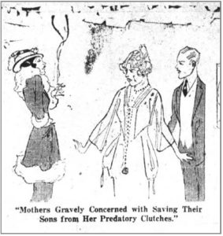

**Source 2:** An excerpt from an article titled ‘Her Eternal Youth’ published in the New York Times on July 2nd, 1922.

There is nothing secretive about the modern girl. The planks in her platform are frankness, common sense and comfort. She refuses to wear uncomfortable clothes because her grandmother considers them ladylike. When conventions interfere with comfort, conventions must go, assert the flapper. Her teachers and professors give her credit for sense and decision. They tell you she is neither bad, nor is she different from the young of other years.

**Source 3:** A poster showing two children standing outside a saloon, was issued by the Anti-Saloon League. It first appeared in the Chicago *Sun Times*. The caprion reads, “*Daddy’s in there – And Our Shoes and Stockings and Clothes and Food Are in There, Too, and They’ll Never Come out.*”

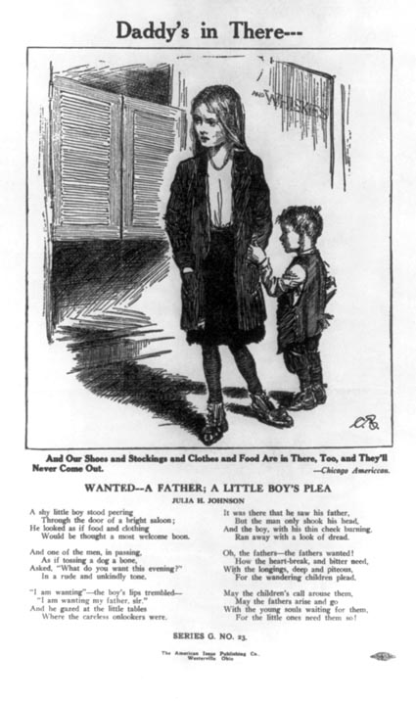

**Source 4:** A political cartoon published in the Chicago Daily Tribune, April 29th 1926.

